**Name: Smruti Padhi**

**Roll No.: 21251**

**Sec: CSE C**

Questions:

1. Write a bash script to echo your name 25 times?

ANS.

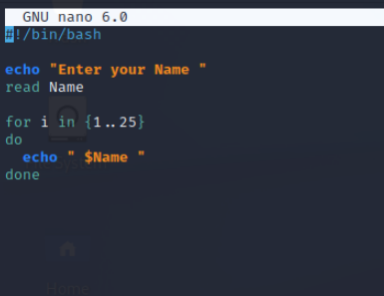

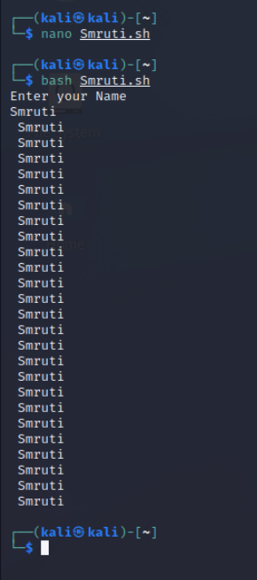

1. What command should I use to display the **first** 30 entries of syslog file?

ANS.

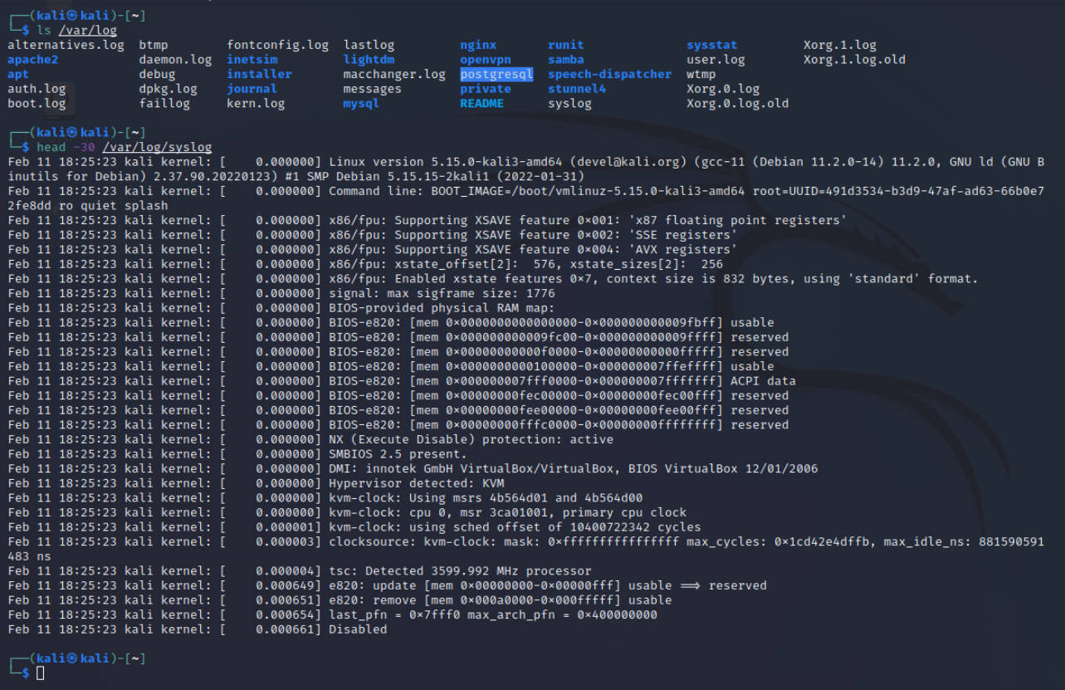

1. What command should I use to display the **last** 30 entries of syslog file?

ANS.

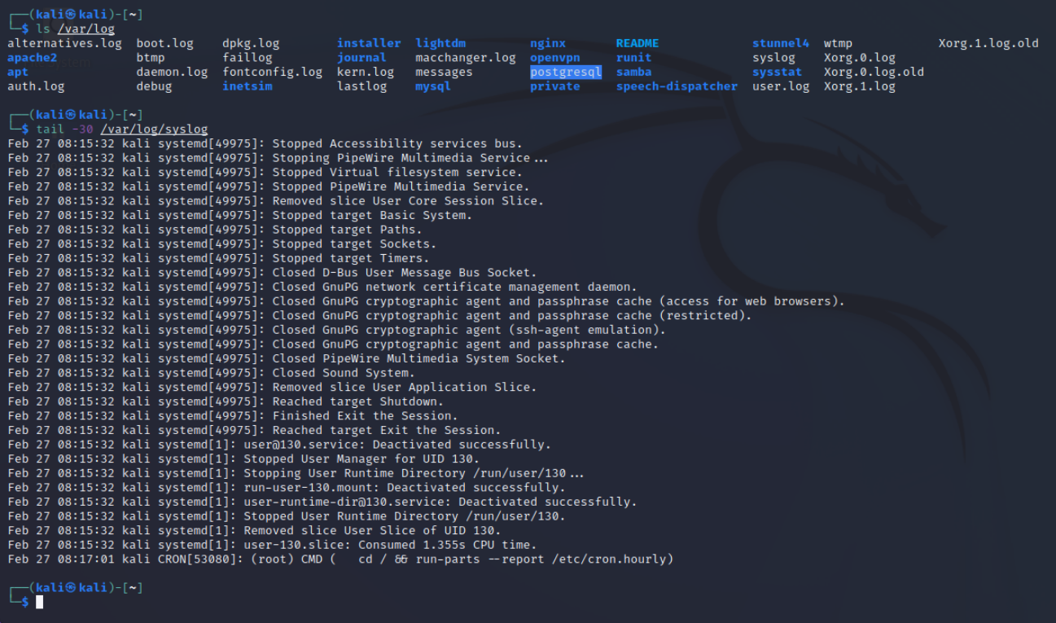

1. What command should I use to arrange the entries of a file?
   * 1. Alphabetical

ANS.

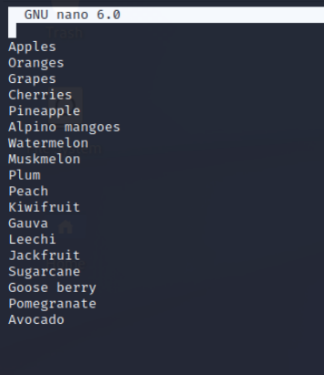

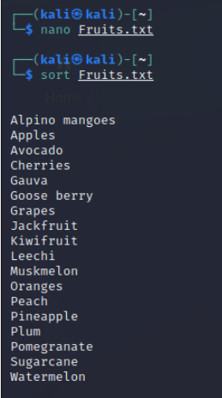

* + 1. Reverse order

ANS.

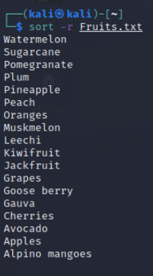

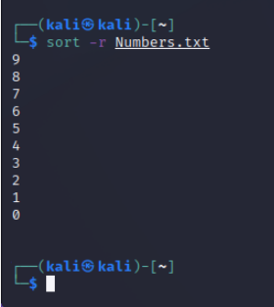

* + 1. Numerical order

ANS.

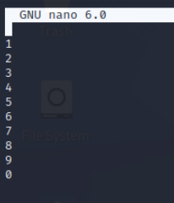

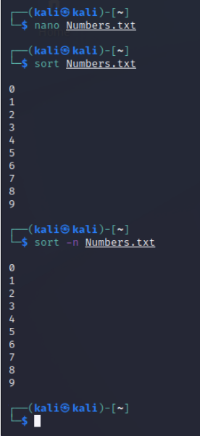

1. Copee is a hard-working cop. He found a case and almost at the verge of cracking it. It could be his best breakthrough. He has the list of criminals but lots of duplicates are there. He needs to find the only one that is **different.** He sought your help. How will you sort this issue?

ANS.

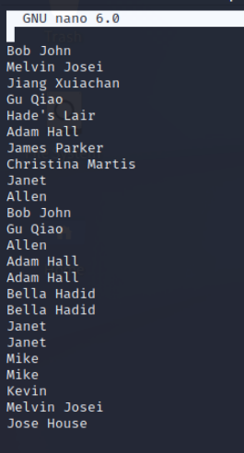

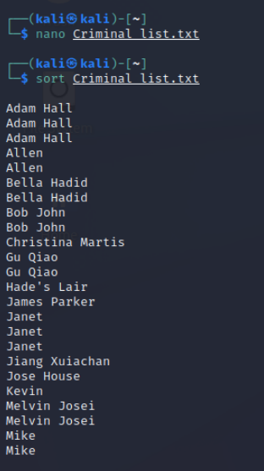

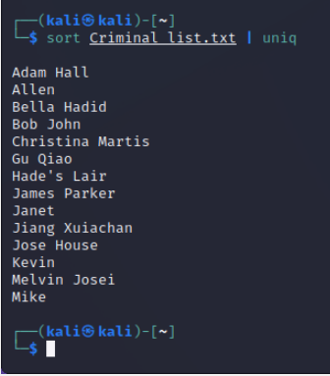

1. What are the Three parts of file's permission?

ANS.

Read (r) : Allows to read a file.

Write (w) : Allows to make changes to the content of the file.

Execute (x) : Allows to use the file as a command.

